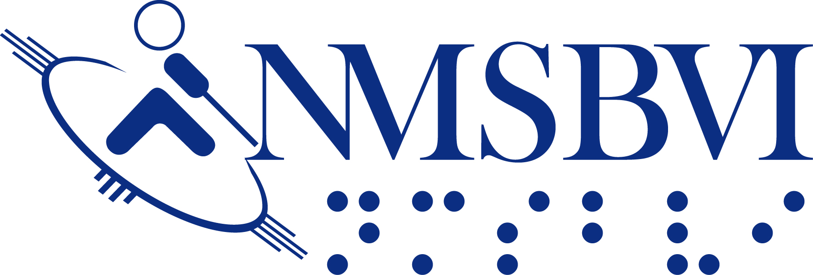
IRC ~ Equipment, Material & Supply Order Form
for NMSBVI STAFF
Use this form to request paper, equipment or other non-textbook items from the IRC Bookroom. Please use
the Textbook Request Form to request textbooks. Allow at least 24 hours for your request to be processed.

To submit form electronically: save this file to your computer; click on grayed spaces and type to fill in fields (you can tab between them); save final file
to your computer; and email your final file as an attachment to IRC@nmsbvi.k12.nm.us .

OR, to submit form via fax: you can print this blank form, fill it in manually, and then fax the printout to (575) 439-4498.
Questions? Please call the IRC at Ext. 4437.

Staff Member’s Name: Date of Request:
Class Location: On Campus Bldg: Room #:
Off Campus
Telephone Extension No.:

Quantity Catalog No. Page # Title or Description Status of Order
(IRC USE ONLY)

IRC USE ONLY
Order Number
Date Received Signature of Person Requesting Items:
(Revised Sep 2018)

