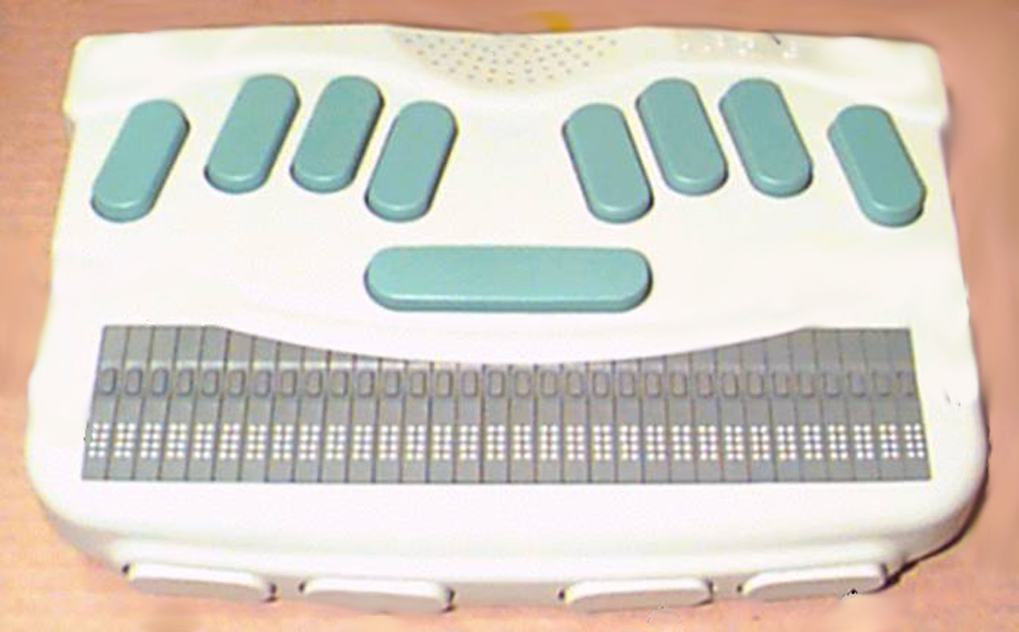
Sentences
Words
Characters
Advanced Edit
Deleting
Sentence
Word
Character
Paragraph
Paragraph
Space Bar
1
2
3
4
5
6
Backspace — delete character to the left of the cursor.
Delete previous character — 3+backspace
Delete current character — 36+backspace
Delete previous word — 2+backspace
Delete current word — 25+backspace

* Delete to the end of sentence — 14+backspace
* Delete to the end of paragraph — 2356+backspace
* Delete to the end of document — 456+backspace

* Requires an affirmative response Y=yes, N=no
Keys with Backspace
Thumb 2
Thumb 1
Thumb 3
Thumb 4
Delete Menu — 145+spacebar
(Then spacebar to go through choices or First letter navigation, )
character — C
word — W

* Cursor to end of sentence — S
* Cursor to end of paragraph — P
* Cursor to end of document — D

Cursor routing keys
Backspace key
Advanced Edit
Deleting
Paragraph
Paragraph
Space Bar
1
2
3
4
5
6
Backspace — delete character to the left of the cursor.
Delete previous character — 3+backspace
Delete current character — 36+backspace
Delete current word — 25+backspace
Delete previous word — 2+backspace

*Delete to the end of sentence — 14+backspace
*Delete to the end of paragraph — 2356+backspace
*Delete to the end of document — 456+backspace

* Requires an affirmative response Y=yes, N=no
Keys with Backspace
Thumb 2
Thumb 1
Thumb 3
Thumb 4
Delete Menu — 145+spacebar
(Then spacebar to go through choices)
C — character
W — word

S — cursor to end of sentence
P — cursor to end of paragraph
D — cursor to end of document
Cursor routing keys
Backspace key
Next
Previous
Current

