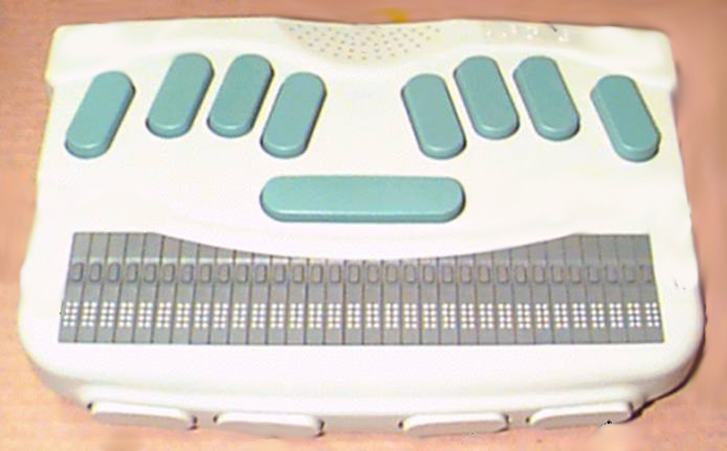
Navigation
Moving
Sentences
Words
Characters
Back
Forward
Paragraph
Paragraph
Space Bar
1
2
3
4
5
6
Top of document — 123+space
Bottom of document — 456+space
Read all — 1245+space (stop—backspace+enter)
Current sentence — 14+space
Current word — 25+space
Spell current word — 25+space (twice)
Current character — 36+space
Current character sound clue 36+space (twice)
Keys with space bar
Thumb 2
Thumb 1
Thumb 3
Thumb 4
Thumb key 1 — up one line
Thumb key 2 — back one display width
Thumb key 3 — forward one display width
Thumb key 4 — down one line
** Thumb keys do not move the cursor; route
the cursor with the cursor routing keys.
Scroll forward with Braille display — 12456+space
Thumb key 4 — faster
Thumb key 1 — slower

Cursor routing keys
Navigation
Moving
Sentences
Words
Characters
Back
Forward
Paragraph
Paragraph
Space Bar
1
2
3
4
5
6
Top of document — 123+space
Bottom of document — 456+space
Read all — 1245+space (stop—backspace+enter)
Current sentence — 14+space
Current word — 25+space
Spell current word — 25+space (twice)
Current character — 36+space
Current character sound clue 36+space (twice)
Keys with space bar
Thumb 2
Thumb 1
Thumb 3
Thumb 4
Thumb key 1 — up one line
Thumb key 2 — back one display width
Thumb key 3 — forward one display width
Thumb key 4 — down one line
** Thumb keys do not move the cursor; route
the cursor with the cursor routing keys.
Scroll forward with Braille display — 12456+space
Thumb key 4 — faster
Thumb key 1 — slower

Cursor routing keys
Navigation
Moving
Sentence
Word
Character
Back
Forward
Paragraph
Paragraph
Space Bar
1
2
3
4
5
6
Top of document — 123+space
Bottom of document — 456+space
Read all — 1245+space (stop—backspace+enter)
Current sentence — 14+space
Current word — 25+space
Spell current word — 25+space (twice)
Current character — 36+space
Current character sound clue 36+space (twice)
Keys with space bar
Thumb 2
Thumb 1
Thumb 3
Thumb 4
Thumb key 1 — up one line
Thumb key 2 — back one display width
Thumb key 3 — forward one display width
Thumb key 4 — down one line
** Thumb keys do not move the cursor -
route the cursor with the cursor routing keys.
Scroll forward with Braille display — 12456+space
Thumb key 4 — faster
Thumb key 1 — slower

Cursor routing keys
Current

