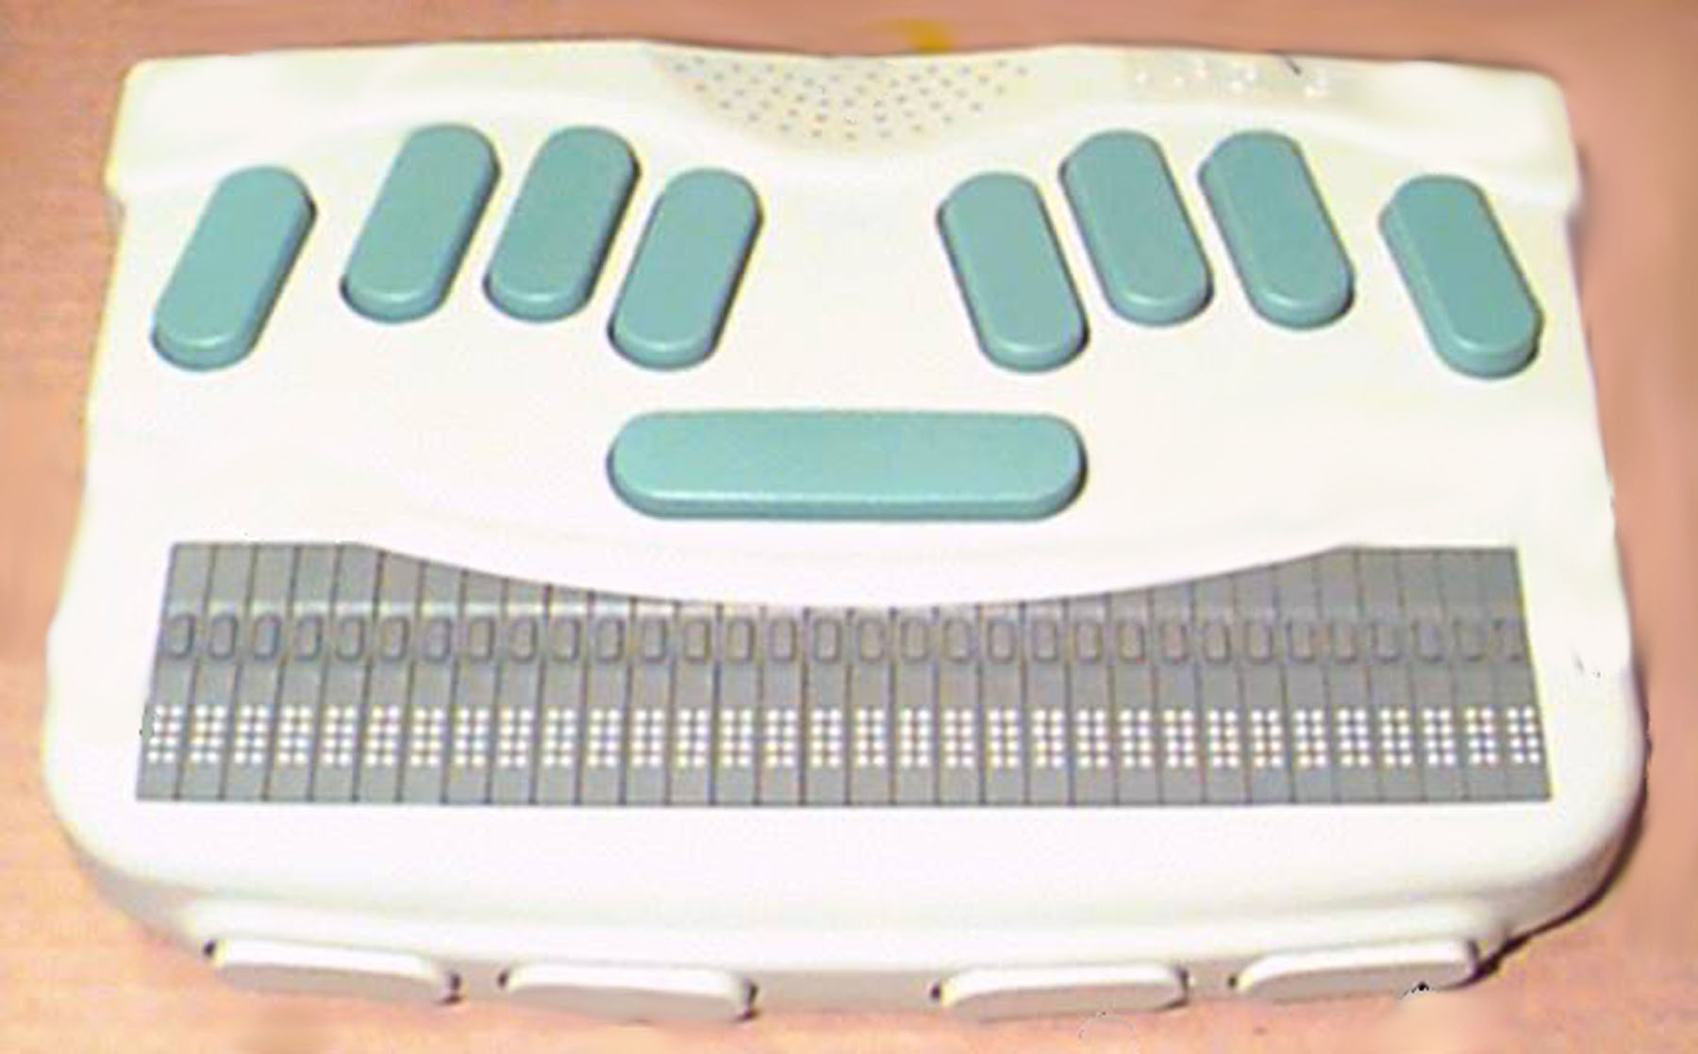
Speech Settings
Volume
Pitch
Speed
Minus
Plus
No Function
No Function
Space Bar
1
2
3
4
5
6
Speech on, Speech on Request, Speech off – Space + Thumb1

Braille on, Braille off – Space + Thumb 4

One-hand mode - Backspace while turning BN on
(For students with the use of only one hand)

Two-hand (normal) – Enter while turning BN on
Keys with Enter
Thumb 2
Thumb 1
Thumb 3
Thumb 4
Enter key
Backspace

