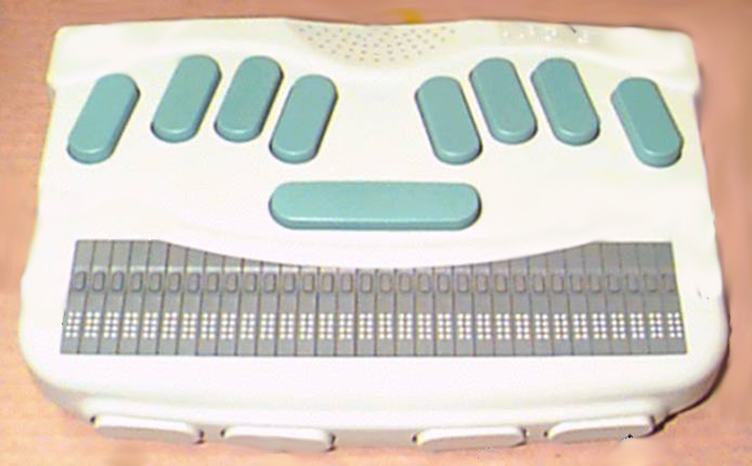
Web Browser

Sentence
Word
Character
Back
Forward
Back Paragraph
Next Paragraph
Space Bar
1
2
3
4
5
6
Top of page — 123+space
Bottom of page — 456+space
Read page — 1245space
Stop reading — Enter+Backspace
Forward through links — spacebar
Backward through links — backspace
Go to current link— Enter key or cursor routing key
Go to first edit field – 46+space
(Computer Braille – no contractions)
Keys with space bar
Thumb 2
Thumb 1
Thumb 3
Thumb 4
Open a web page – O+Enter (Computer Braille)
Back a page – B+Enter
Forward a page – F+Enter
Say current web page – I+Enter
Refresh web page – R+Enter
Opens Favorites menu – 235+Enter

Block Commands menu – B+Space
Top of block – t; Bottom of block – b
Copy block of text – c; Past text on clipboard - p

Cursor routing keys
Current
Backspace
Enter
Jump to next paragraph – 56+Enter

