

ZoomText
Quick Reference Guide
8.1
version

Contents

Welcome to ZoomText 8.1 2
System Requirements 3
Installing ZoomText 4
Starting ZoomText 5
ZoomText User Interface 6
Enabling and Disabling ZoomText 8

Magnifier Toolbar 9
Setting the Magnification level 10
Selecting a Zoom Window 11
Adjusting a Zoom Window 13
Using the Freeze Window 14
Using View Mode 15
Color Enhancements 16
Pointer Enhancements 17
Cursor Enhancements 18
Using the Desktop Finder 19
Using the Web Finder 20
Reader Toolbar 21
Turning Speech On and Off 22
Adjusting the Speech Rate 23
Synthesizer Settings 24
Typing Echo 25
Mouse Echo 26
Verbosity 27
AppReader 28
DocReader 30
SpeakIt Tool 33
Text Reading Commands 34

Hotkeys 36
Configuration Files 47
The Default Configuration File 48

Welcome to ZoomText 8.1
ZoomText 8.1 is a powerful computer access solution for vision-impaired individuals. Consisting of two adaptive technologies – screen magnification and screen reading – ZoomText allows you to see and hear everything on the computer screen, providing complete access to applications, documents, email and the Internet.
ZoomText 8.1 is available in two product versions:
Magnifier – a standalone screen magnifier
Magnifier/ScreenReader – an integrated magnifier and screen reader

This quick reference guide provides helpful information on installing and using
the key features of ZoomText Magnifier and ZoomText Magnifier/ScreenReader. Features associated with screen reading and speech are only available in ZoomText Magnifier/ScreenReader.
Note: This guide does not describe all of the features of ZoomText 8.1, nor is it intended to replace the full documentation. For complete information, refer
to the ZoomText user's guide or online help system. To launch the online
help system, select Help  ZoomText Help in the ZoomText menu bar.

System Requirements
To run ZoomText 8.1 you must have a system that includes the following:
- Celeron, Pentium II or higher, AMD K6 or higher
- One of the following operating systems:
Windows XP
Windows ME (Millennium Edition)
Windows 2000
Windows NT 4.0 (SP6)
Windows 98
- Minimum 128 MB RAM (256 MB recommended)
- 25 MB free hard disk space
- Sound card (for Magnifier/ScreenReader version only)

Installing ZoomText
When you insert the ZoomText CD into your CD-ROM drive, the Setup program will start automatically. Follow the on-screen instructions to complete the installation.
- If Setup does not start automatically
- Click on the Windows Start button and select Run…
- Browse to your CD-ROM drive.
- Select the Setup program and click Open.
- Click OK in the Run dialog box.
Installing ZoomText in Windows XP, 2000 and NT 4.0
When you run Setup in Windows XP, 2000 or NT 4.0, the setup program will install system-level components. In order to install these components you must have administrator privileges. If you do not have these privileges, contact your system administrator before proceeding with the installation.
- To uninstall ZoomText
- Make sure ZoomText is not running.
- In the Start menu, choose Programs  ZoomText 8.1  Uninstall ZoomText 8.1.
- Follow the on-screen instructions.

Starting ZoomText
Once ZoomText is installed on your system, it can be started using one of the following procedures.
- To start ZoomText
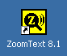 | Do one of the following:  - On the Windows desktop, click on the ZoomText 8.1 icon.  - In the Windows Start menu, choose Programs  ZoomText 8.1  ZoomText 8.1.

When ZoomText starts up it changes your display to show a magnified view of the normal screen. As you move the mouse, type text and navigate your applications, the magnified view automatically scrolls, keeping the area of activity in view.
If you have installed ZoomText Magnifier/ScreenReader, ZoomText will also speak
aloud, narrating your actions as you work with your documents and applications. All of your Windows programs will operate normally while ZoomText is active.
- To exit ZoomText
In the File menu, choose Exit.

ZoomText User Interface
When you start ZoomText its user interface appears on the screen. This window contains all of the controls for operating ZoomText. Features associated with magnification and screen reading are grouped into separate toolbars and dialogs.

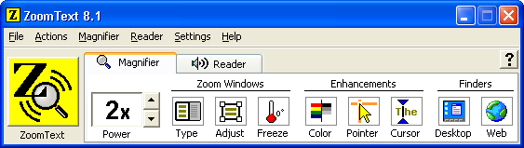
ZoomText button
Enables or disables ZoomText.
Magnifier tab
Displays toolbar controls for ZoomText's magnification features.
Reader tab
Displays toolbar controls for ZoomText's screen reading features.
Help tool
Displays information about clicked-on items in the ZoomText toolbars.
Minimize button
Hides the ZoomText user interface.

ZoomText User Interface (continued)
The ZoomText user interface can be minimized (hidden) and restored (made visible), without affecting the operation of ZoomText.
- To minimize ZoomText
Do one of the following:
- Click on the minimize button.
- While the ZoomText user interface is active, press ESC.
- To restore ZoomText
Do one of the following:
- Click on the ZoomText 8.1 button in the task bar.
- Press the Display User Interface hotkey: CTRL + SHIFT + U.

Enabling and Disabling ZoomText
When ZoomText is run on your system, it automatically begins magnifying and reading your screen. You can enable and disable ZoomText at any time, without exiting the program. When disabled, ZoomText returns the screen to its normal (unmagnified) state and all speech output is terminated.
- To enable ZoomText
Do one of the following:
- On the ZoomText user interface, click on the ZoomText button.
- Press the Enable ZoomText hotkey: ALT + INSERT.
- To disable ZoomText
Do one of the following:
- On the ZoomText user interface, click on the ZoomText button.
- Press the Disable ZoomText hotkey: ALT + DELETE.

Magnifier Toolbar
The Magnifier toolbar provides quick access to ZoomText's magnification features. Each toolbar button has an intuitive icon and label for easy identification. Many of these buttons have pop-up menus that provide fast access to the most important and frequently used settings. Related buttons are grouped together and the group is labeled with a clickable link that opens their associated dialog box. Features associated with this toolbar are described in pages 10 through 20.

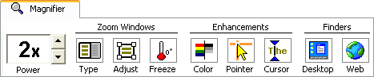
The Magnifier toolbar

Setting the Magnification Level
ZoomText provides a wide range of magnification levels, allowing you to enlarge the view according to your needs. Magnification levels range from 1x to 16x (1x to 8x in steps of 1, 10x to 16x in steps of 2, and fractional powers of 1.25x, 1.5x and 1.75x).
- To adjust the magnification level
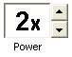 | On the Magnifier toolbar, adjust the level in the Power spinbox,  OR use the Magnification hotkeys:
  To… | Press…
  Increase magnification | ALT + NUMPAD PLUS
  Decrease magnification | ALT + NUMPAD MINUS

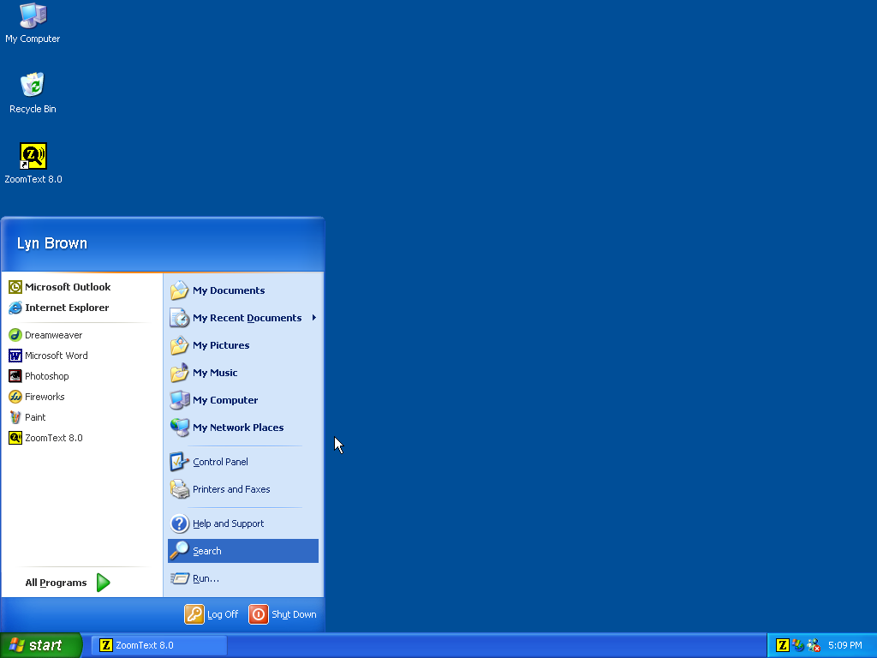 | 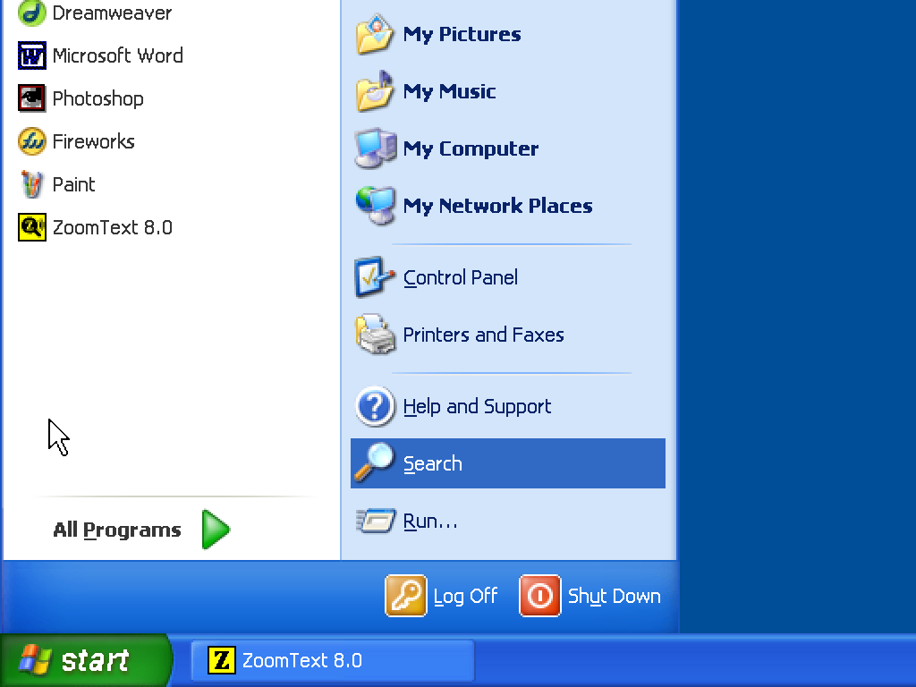 | 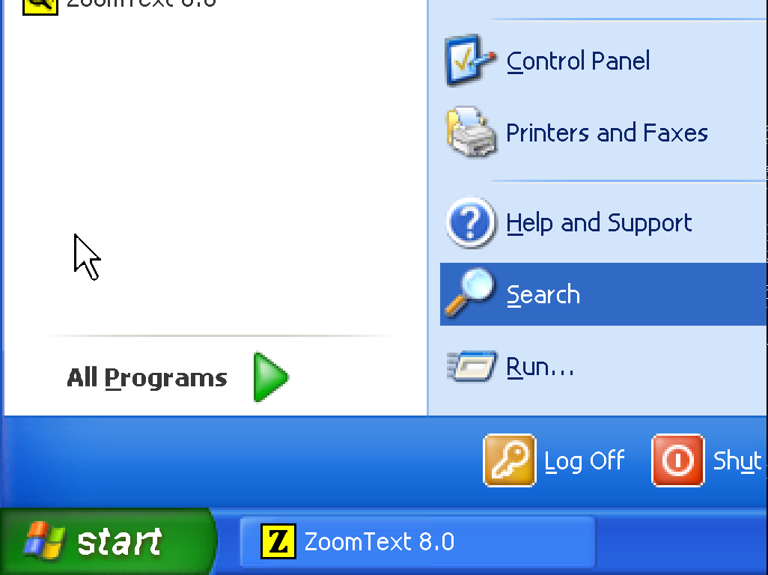
1x view (normal screen) | 2x View | 3x View

Selecting a Zoom Window
ZoomText provides eight zoom window types: Full, Overlay, Lens, Line and four Docked positions. Each of these windows offers a unique way of viewing what is on the screen. At any time, you can switch zoom window types to accommodate a different task or application environment.
- To select a zoom window type
 | On the Magnifier toolbar, select Type, and then select the desired zoom window.  You can also cycle through the zoom window types by pressing  the Zoom Window hotkey: CTRL + SHIFT + Z.

Selecting a Zoom Window (continued)
Zoom Window Types
Full displays a magnified view that occupies the entire screen. |  |  | 
Overlay displays a magnified view that can be sized and moved to occupy any portion of the screen. |  |  | 
Lens moves over the normal screen like a magnifying glass, displaying what is directly beneath it. The lens automatically follows as you move the mouse pointer, type text and navigate your programs. |  |  | 
Line moves up and down the screen like a magnifying ruler, displaying what is directly beneath it. The line window automatically follows as you move the mouse pointer, type text and navigate your programs. |  |  | 
Docked splits the screen in half, displaying a magnified 'docked' view on one side and a normal (unmagnified) view on the other. The magnified view can be docked against any edge of the screen: top, bottom, left, or right. |  |  | 
 |  |  | 

Adjusting a Zoom Window
ZoomText's windows can be sized and/or moved to occupy a different portion of the screen (with the exception of Full zoom).
- To size and move a zoom window
 | - On the Magnifier toolbar, select the Adjust tool.  Sizing handles appear on the frame of the zoom window.  - To size the window, drag any handle.  - To move the window, drag inside the window frame.  - To scroll the contents of the window, hold down CTRL,  and then drag inside the window frame.  - To exit the Adjust tool, right-click or press ESC.  Note: The Adjust tool is grayed out when the Full zoom window  is active.

Using the Freeze Window
The Freeze window allows you to monitor information at one location while you simultaneously view and edit information at other locations. The Freeze window sits on top of the Full zoom window displaying your selected freeze location. The Full zoom window continues to scroll and display all areas of the screen.
- To set up a Freeze window
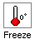 | - Set the zoom window type to Full.  - On the Magnifier toolbar, select Freeze  New.  - Move the mouse pointer to scroll the desired freeze area into view.  - Drag to select the freeze area.  The Freeze window appears with sizing handles on the frame.  - To size the window, drag any handle. To move the window, drag inside the window frame. To scroll the contents of the window, hold down CTRL and drag inside the window frame.  - To exit the Freeze tool, right-click or press ESC.  Note: The Freeze window can be adjusted using the Adjust tool.
- To enable and disable the Freeze window
On the Magnifier toolbar, select Freeze  Enable (or Disable).

Using View Mode
View mode shows you the area of the screen that’s currently being magnified, and allows you to select a new area to zoom in on. When view mode is activated, magnification turns off and the view locator appears in the normal screen. By moving the view locator, you can select a new area to zoom in on.
- To use View Mode
- In the Actions menu, choose View Mode.
Magnification is temporarily turned off and the view locator appears.
- Move the view locator to the desired screen location.
- Click to zoom-in on the new location.
Magnification is restored with the selected screen area displayed.
You can configure the view locator to appear in a variety of shapes and colors. The view locator can also be enabled to appear in normal (unmagnified) portions of the screen when using Overlay or Docked zoom windows.
- To configure the view locator
- In the Magnifier menu, choose View Locator...
- Adjust the locator options as desired.
- Click the OK button.

Color Enhancements
Color enhancements improve clarity of text and graphics, providing easier viewing and reduced eyestrain. The color enhancement options consist of a variety of filter effects that adjust color, contrast and brightness. You can choose from preset color schemes or configure your own custom color settings.
- To choose a preset color scheme
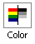 | On the Magnifier toolbar, select Color  Scheme, and then select the desired color scheme.
- To configure custom color settings
- In the Magnifier menu, choose Color Enhancements...
- Select Custom...
- Adjust the custom settings as desired.
- Click the OK button.

Pointer Enhancements
Pointer enhancements make it easy to locate and follow the mouse pointer. You can adjust the size and color of the pointer, and activate a locator that emphasizes the pointers position on the screen. You can choose from preset pointer schemes or configure your own custom pointer settings.
- To choose a preset pointer scheme
 | On the Magnifier toolbar, select Pointer  Scheme, and then select the desired pointer scheme.
- To configure custom pointer settings
- In the Magnifier menu, choose Pointer Enhancements...
- Select Custom...
- Adjust the custom settings as desired.
- Click the OK button.

Cursor Enhancements
Cursor enhancements make it easy to locate and follow the text cursor. A choice of high visibility locators marks the cursor’s position, without obscuring the surrounding text. You can choose from preset cursor schemes or configure your own custom cursor settings.
- To choose a preset cursor scheme
 | On the Magnifier toolbar, select Cursor  Scheme, and then select the desired cursor scheme.
- To configure custom cursor settings
- In the Magnifier menu, choose Cursor Enhancements...
- Select Custom...
- Adjust the custom settings as desired.
- Click the OK button.

Using the Desktop Finder
The Desktop Finder helps you find and open programs and documents located in the Windows desktop environment - including the quick launch bar, system tray and control panel. When executing the Desktop Finder, a dialog box displays a list of items located in the desktop environment. This list can be filtered and searched, allowing you to quickly locate the desired item. Desktop Finder 'Actions' allow you to open the item or view its properties.
- To use the Desktop Finder
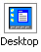 | - On the Magnifier toolbar, select Desktop.  The Desktop Finder dialog appears.  - Filter and sort the Desktop Items list by selecting the desired options under Show These Items and Sort Items By.  - To narrow the search, type the information you are searching for in the Search combo box, or select a recent entry from the combo box list.  - Select the desired item in the Desktop Items list.  - Click the Open button to launch the selected item, or the Properties button to view the properties for the selected item.

Using the Web Finder
The Web Finder helps you find links and controls in Internet Explorer, HTML email, and HTML Help systems. When executing the Web Finder, a dialog box displays a list of links and controls in the last active HTML document. This list can be filtered and searched, allowing you to quickly find the desired item. Web Finder 'Actions' allow you to execute a selected link, scroll to a link or control, or begin reading (with AppReader) at the location of a link or control.
- To use the Web Finder
 | - On the Magnifier toolbar, select Web.  The Web Finder dialog appears.  - Filter and sort the Web Page Items list by selecting the desired options under Show These Items and Sort Items By.  - To narrow the search, type what you are searching for in the Search combo box, or select a recent entry from the combo box list.  - Select the desired item in the Web Page Items list.  - Click the Execute Link button to execute the selected link. Click the Scroll To button to scroll the selected item into view. Click the Read From button to begin reading (with AppReader) at the location of the selected item.

Reader Toolbar
The Reader toolbar provides quick access to ZoomText's screen reading features.
Each toolbar buttons has an intuitive icon and label for quick identification. Many of these buttons have pop-up menus that provide fast access to the most important and frequently used settings. Related buttons are grouped together and the group is labeled with a clickable link that opens their associated dialog box. Features associated with this toolbar are described in pages 22 through 34.

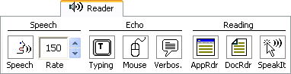
The Reader toolbar

Turning Speech On and Off
You can turn speech output on and off without disabling the magnification features.
- To enable and disable speech
 | On the Reader toolbar, select Speech  Enable (or Disable),  OR, press the Speech On/Off hotkey: ALT + SHIFT + S  Note: AppReader, DocReader and the SpeakIt tool can be used when speech is disabled.

There may be times when you want to terminate speech output while it is occurring. For example, when ZoomText is reading a message box that you are already familiar with. You can force ZoomText to stop speaking this text without turning speech off altogether.
- To terminate speech output as it occurs
Press and release the CTRL key.
The information that is currently being spoken is terminated.

Adjusting the Speech Rate
By adjusting the speech rate, you can control how fast ZoomText speaks (in words per minute).
- To adjust the speech rate
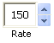 | On the Reader toolbar, adjust the level in the Rate spinbox,  OR, use the Speech Rate hotkeys:  A separate speech rate is available for AppReader and DocReader. This setting is located in the Reading Options dialog box. In the Reader menu, choose Reader Options…
  To… | Press…
  Increase speech rate | CTRL + NUMPAD PLUS
  Decrease speech rate | CTRL + NUMPAD MINUS

Note: Additional speech synthesizer settings, including voice, pitch and volume, can also be adjusted. To adjust these settings, in the Reader menu, choose Synthesizer…

Synthesizer Settings
Synthesizer settings let you to customize the screen reading voice. You can select from a variety of male and female voices, and adjust their speaking rate, pitch and volume.
Note: ZoomText comes with three speech synthesizers: TruVoice, ViaVoice and Microsoft Speech. The ZoomText Setup program allows you to install any combination of these synthesizers. ZoomText also supports other SAPI based synthesizers that have been installed on your system.
- To adjust the speech synthesizer settings
- In the Reader menu, choose Synthesizer...
- Make sure the Enable speech output box is checked.
- Choose a synthesizer and voice, and then adjust the rate, pitch and volume as desired.
- To preview the synthesizer settings, type some text in the Sample Text edit box, and then click Speak Sample.
- Click the OK button.

Typing Echo
Typing echo allows you to hear the keys and words that you type. You can choose to have individual keys, words, or both keys and words spoken. Typed words are spoken upon completion (as soon as you type a space or punctuation character). Additional typing echo options also allow you to select which keys are spoken – all keys or selected groups of keys.
- To enable typing echo
 | On the Reader toolbar, click Typing and then select the desired typing echo mode.
- To adjust the typing echo options
- In the Reader menu, choose Typing Echo...
- Adjust the typing echo options as desired.
- Click the OK button.

Mouse Echo
Mouse echo automatically reads text beneath the pointer. As you move the pointer across the screen, single words or complete lines of text are echoed instantly or after hovering briefly.
- To enable mouse echo
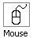 | On the Reader toolbar, click Mouse and then select the desired mouse echo mode.
- To adjust the mouse echo options
- In the Reader menu, choose Mouse Echo...
- Adjust the mouse echo options as desired.
- Click the OK button.

Verbosity
Verbosity allows you to adjust the amount of information spoken about program controls when they become active or highlighted. Program controls include: application and document windows, menus, dialogs, buttons, icons, and more.
Three verbosity levels – Beginner, Intermediate and Expert – allow you to quickly increase or decrease the verbosity. Beginner verbosity provides more information, while Expert verbosity provides less information. Each of these verbosity levels can be fully customized according to your personal needs.
- To select a verbosity level
 | On the Reader toolbar, click Verbos. and then select the desired verbosity level.
- To adjust the verbosity options
- In the Reader menu, choose Verbosity...
- Adjust the verbosity options as desired.
- Click the OK button.

AppReader
AppReader reads documents, web pages and email, within the parent application. As you enter and exit AppReader your view of the document does not change, providing quick and seamless transitions between document editing and reading.
AppReader can automatically read through the entire document, or you can manually read by word, line, sentence or paragraph. As reading occurs, each spoken word is highlighted. AppReader settings allow you to customize the appearance of word highlighting, including the highlight shape, size, color, and transparency level.
- To adjust the AppReader settings

- In the Reader menu, choose AppReader...
- Adjust the AppReader settings as desired.
- Select the OK button.
AppReader highlighting

AppReader (continued)
- To start and operate AppReader
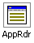 | - Open the document, web page or email that you wish to read.  - Press the AppReader hotkey: ALT + SHIFT + A,  OR, on ZoomText's Reader toolbar, click the AppRdr button.  AppReader begins reading from the current text cursor position. If a text cursor does not exist, AppReader starts paused with the first word on the page highlighted.  Note: The AppReader button is disabled (grayed out) when the last active application does not contain readable text.  - To start and stop automatic reading, press ENTER  OR, click the mouse.  When using the mouse, you can resume reading from a new location by clicking on the word where you wish to read.  - To read manually, use the AppReader navigation commands (see "AppReader and DocReader Commands" on page 37).  - To exit AppReader, right-click or press ESC.  When AppReader exits, the cursor is automatically positioned at the last word that was highlighted in AppReader (if a cursor exists).

DocReader
DocReader reads documents, web pages, and email, in a special environment
where text is reformatted for easier viewing. Text is presented in a ticker tape or
teleprompter format, with your choice of fonts, colors, word highlighting, and magnification level.
DocReader can automatically read through an entire document, or you can manually read by word, line, sentence or paragraph. As reading occurs, each spoken word is highlighted.

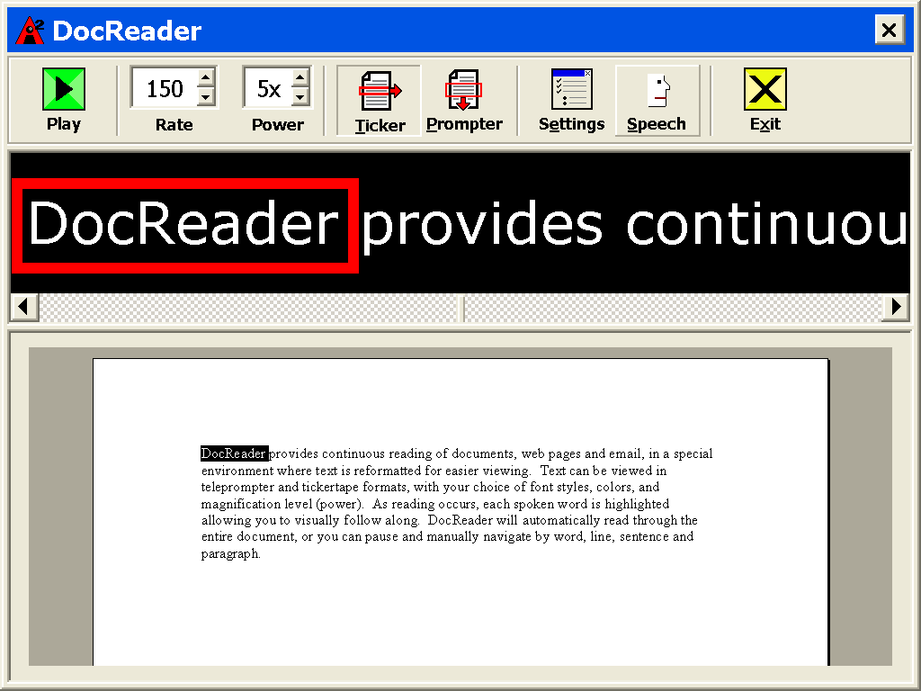  Ticker mode | 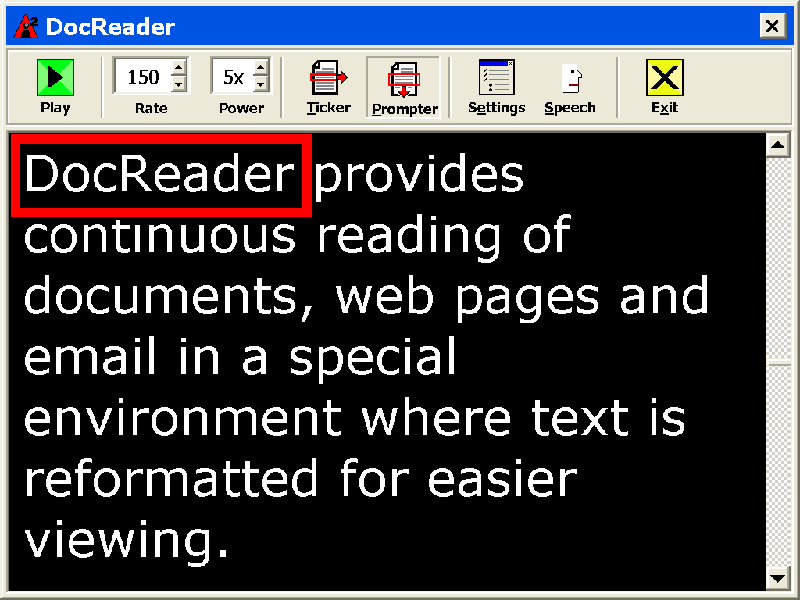  Prompter mode

DocReader (continued)
- To start and operate DocReader
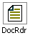 | - Open the document, web page or email that you wish to read.  - Press the DocReader hotkey: ALT + SHIFT + D,  OR, on ZoomText's Reader toolbar, click the DocRdr button.  The DocReader screen appears with text from the source document.  If the source document contains an active text cursor, the word at the cursor position is highlighted in the DocReader display. Otherwise, the first word in the DocReader screen is highlighted.  Note: The DocReader button is disabled (grayed out) when the last active application does not contain readable text.
  - To start and stop automatic reading, click the Play/Pause button OR, press Enter.
While paused, you can click any word to set a new location to read from.
  - To read manually, use the DocReader navigation commands
(see "AppReader and DocReader Commands" on page 37).
  - To exit DocReader, right-click or press ESC.
When DocReader exits, the text cursor is automatically positioned at the last word that was highlighted in DocReader (if a cursor exists).

DocReader (continued)
The DocReader toolbar provides controls for operating DocReader and accessing settings that modify the appearance of text and highlighting.
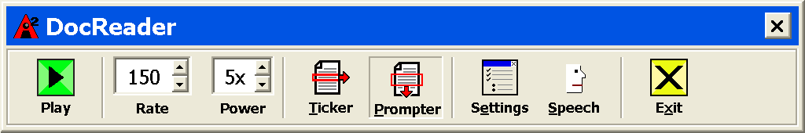
DocReader toolbar

Play/Pause Starts and stops reading at the highlighted word.
Rate Controls how fast DocReader speaks – in words per minute.
Power Sets the magnification level used by DocReader, from 1x to 16x.
Ticker Displays a single line of text that scrolls horizontally like a tickertape,
along with a 1x view of the source document that appears beneath.
Prompter Displays multiple wrapped lines of text that scroll vertically like
a teleprompter.
Settings Opens the Reading dialog box to change the DocReader settings.
Speech Opens the Speech dialog box to change the speech settings.
Exit Exits DocReader and activates the source application.

SpeakIt Tool
The SpeakIt tool allows you to read selected areas of the screen by clicking or dragging with the mouse. Any text that is visible on the screen can be spoken, even if it is outside the active program. Note: Text that appears in graphical images cannot be spoken.
- To use the SpeakIt tool
 | - On the Reader toolbar, click the SpeakIt button,  OR, press the SpeakIt Tool hotkey: ALT + SHIFT + I  - To speak a single word, click on the word.  - To speak a block of text, drag to highlight the text.  Upon release of the mouse button, all highlighted text will be spoken.  - To exit the SpeakIt tool, right-click or press ESC.

Text Reading Commands
Text reading commands let you navigate and read while creating and editing documents (by word, line, sentence or paragraph). When using these commands, the text cursor moves in accordance with the command. For example, when pressing the Say Next Sentence command, the cursor moves to the beginning of the next sentence and the entire sentence is spoken. The following table lists the text reading commands.
Note: Num Lock must be turned off when using ZoomText commands that utilize the numeric keypad.
Text Reading Commands | Keys
Say Previous Character | LEFT
Say Current Character  | NUMPAD 5
Say Next Character | RIGHT
Say Previous Word | CTRL + LEFT
Say Current Word  | CTRL + NUMPAD 5
Say Next Word | CTRL + RIGHT
Say Previous Sentence | CTRL + ALT + LEFT
Say Current Sentence | CTRL + ALT + NUMPAD 5
Say Next Sentence | CTRL + ALT + RIGHT

Text Reading Commands (continued)
Text Reading Commands (continued) |  | Keys
Say Previous Line  |  | UP
Say Current Line |  | SHIFT + NUMPAD 5
Say Next Line  |  | DOWN
Say Previous Paragraph |  | CTRL + UP
Say Current Paragraph |  | CTRL + SHIFT + NUMPAD 5
Say Next Paragraph |  | CTRL + DOWN
⬥ | Second press of the Say Current Character command speaks the character phonetically ("Alpha, Bravo, Charlie...")
 | Repeated presses of the Say Current Word command operates as follows:  - First press: speaks the word  - Second press: spells the word  - Third press: spells the word phonetically ("Alpha, Bravo, Charlie...")  Note: Repeated presses must occur within two seconds.
 | This command reads the current word or entire line according to the Program Echo setting 'When the text cursor moves into a new line'.

Hotkeys
Hotkeys are key combinations that execute ZoomText commands without having to activate the ZoomText interface. Hotkeys exist for almost all ZoomText features, allowing you to control ZoomText while another application is active.
Some important facts about ZoomText hotkeys are:
- Hotkeys can be changed or disabled to eliminate conflicts with other programs.
- Both keys and mouse buttons can be used to define a hotkey.
- Each hotkey must be unique.
Each hotkey consists of one or more modifier keys and a single primary key. The modifier keys consist of any combination of ALT, CTRL, SHIFT and the Windows Key. The primary key can be any other key or any mouse button.
- To change hotkey settings
- In the Settings menu, choose Hotkeys...
- Select the desired Hotkey Group and Hotkey Command.
- Adjust the hotkey combination as desired.
- Repeat steps 2 and 3 for each hotkey you wish to modify.
- Click the OK button.

Hotkeys
AppReader and DocReader Commands
General commands | Keys
Start AppReader | ALT + SHIFT + A
Start DocReader | ALT + SHIFT + D
Toggle Reading (Play/Pause) | ENTER
Increase Magnification | ALT + NUMPAD PLUS
Decrease Magnification | ALT + NUMPAD MINUS
Increase Reading Rate | CTRL + NUMPAD PLUS
Decrease Reading Rate | CTRL + NUMPAD MINUS
Quiet | CTRL
Exit | ESC

Hotkeys
AppReader and DocReader Commands (continued)
Navigation commands | Keys
Say Previous Word | CTRL + LEFT, OR LEFT
Say Current Word  | CTRL + NUMPAD 5, OR SPACEBAR
Say Next Word | CTRL + RIGHT, OR RIGHT
Say Word Above | UP
Say Word Below | DOWN
Say Previous Sentence | CTRL + ALT + LEFT
Say Current Sentence | CTRL + ALT + NUMPAD 5
Say Next Sentence | CTRL + ALT + RIGHT
Say Previous Paragraph | CTRL + UP
Say Current Paragraph | CTRL + SHIFT + NUMPAD 5
Say Next Paragraph | CTRL + DOWN
Say First Word On Line | HOME
Say Last Word On Line | END

Hotkeys
AppReader and DocReader Commands (continued)
Navigation commands (continued) |  | Keys
Page Up |  | PAGE UP
Page Down |  | PAGE DOWN
Beginning of Document |  | CTRL + HOME
End of Document |  | CTRL + END
Next Link |  | TAB
Previous Link |  | SHIFT + TAB
Execute Link |  | CTRL + ENTER
⬥ | Repeated presses of the Say Current Word operates as follows:  - First press: speaks the word  - Second press: spells the word  - Third press: spells the word phonetically ("Alpha, Bravo, Charlie...")  Note: Repeated presses must occur within two seconds.

Hotkeys
Load Configuration Commands
Commands | Keys
Load Configuration 1…9 | ALT + SHIFT + 1 …9
Magnification Commands
Commands | Keys
Increase Magnification | ALT + NUMPAD PLUS
Decrease Magnification | ALT + NUMPAD MINUS

Hotkeys
Magnifier Toolbar Commands
Commands | Keys
Window Type | CTRL + SHIFT + Z
Adjust Window Tool | CTRL + SHIFT + A
Freeze Window On/Off | CTRL + SHIFT + F
Color Enhancements On/Off | CTRL + SHIFT + C
Pointer Enhancements On/Off | CTRL + SHIFT + P
Cursor Enhancements On/Off | CTRL + SHIFT + R
Desktop Finder | CTRL + SHIFT + D
Web Finder | CTRL + SHIFT + W

Hotkeys
Miscellaneous Commands
Commands | Keys
Locator On/Off | CTRL + SHIFT + L
View Mode On/Off | CTRL + SHIFT + V
Text Smoothing Type | CTRL + SHIFT + T
Mouse To View | CTRL + SHIFT + B
View To Mouse | CTRL + SHIFT + Y
Pass Thru (next ZoomText hotkey) | ALT + PAUSE
AHOI On/Off | CTRL + ALT + SHIFT + A
AHOI Status Report | CTRL + ALT + SHIFT + S
Capture ZoomText Screen | CTRL + ALT + SHIFT + C
Cursor Detect | CTRL + ALT + SHIFT + D
MSAA On/Off | CTRL + ALT + SHIFT + M
Tracking On/Off | CTRL + ALT + SHIFT + T
Update Screen Model | CTRL + ALT + SHIFT + U

Hotkeys
Reader Toolbar Commands
Commands | Keys
Speech On/Off | ALT + SHIFT + S
Increase Speech Rate | CTRL + NUMPAD PLUS
Decrease Speech Rate | CTRL + NUMPAD MINUS
Typing Echo Mode | ALT + SHIFT + T
Mouse Echo Mode | ALT + SHIFT + M
Verbosity Level | ALT + SHIFT + V
Start AppReader | ALT + SHIFT + A
Start DocReader | ALT + SHIFT + D
SpeakIt Tool | ALT + SHIFT + I

Hotkeys
Screen Reading Commands
Commands | Keys
Say Window Title | CTRL + ALT + W
Say Dialog Tab | CTRL + ALT + T
Say Dialog Message | CTRL + ALT + M
Say Focus | CTRL + ALT + F
Say Default Button | CTRL + ALT + B
Say Group Name | CTRL + ALT + G
Say Status Bar | CTRL + ALT + X
Say All | CTRL + ALT + A
Say Selected Text | CTRL + ALT + S
Say Cell Row Title | CTRL + ALT + R
Say Cell Column Title | CTRL + ALT + K
Say Cell Formula | CTRL + ALT + O
Say Cell Comment | CTRL + ALT + C

Hotkeys
Screen Reading Commands (continued)
Commands | Keys
Say Current Time | CTRL + ALT + I
Say Current Date | CTRL + ALT + Y
Read Clipboard | ALT + SHIFT + C
Quiet | ALT + SHIFT + Q, OR CTRL
Change Speech Engine | ALT + SHIFT + E
User Interface Commands
Commands | Keys
Enable ZoomText | ALT + INS
Disable ZoomText | ALT + DEL
Display User Interface | CTRL + SHIFT + U
Help Tool | CTRL + SHIFT + H

Hotkeys
Scroll Commands
Commands | Keys
Scroll Up | ALT + UP
Scroll Down | ALT + DOWN
Scroll Left | ALT + LEFT
Scroll Right | ALT + RIGHT
Jump Up | ALT + PGUP
Jump Down | ALT + PGDN
Jump Left | ALT + HOME
Jump Right | ALT + END
Jump Center | ALT + NUMPAD 5
Save View | ALT + NUMPAD /
Restore View | ALT + NUMPAD *

Configurations Files
All ZoomText settings can be saved and restored using configuration files. Configuration files control all ZoomText features, including magnification level, zoom window type, screen enhancements, reading options and hotkeys. Any number of files can be saved, allowing you to create custom ZoomText configurations that can be recalled at any time.
- To save settings to a configuration file
- Set all ZoomText features as desired.
- In the File menu, choose Save Configuration...
The Save Configuration dialog appears displaying the existing configuration files.
- Type the name of the new configuration in the File name: box.
- Click on the OK button.
- To load settings from a configuration file
- In the File menu, choose Open Configuration...
The Open Configuration dialog appears displaying the existing configuration files.
- Highlight the desired configuration file.
- Click on the Open button.

The Default Configuration
When you start ZoomText, the default configuration file Zt8.zxc, is automatically loaded. This file contains the built-in defaults for all ZoomText settings. You can create your default configuration, which will load your custom settings whenever ZoomText is run. Don't worry about losing the built-in settings – the original default file can be easily restored.
- To save a custom default configuration
- Set all ZoomText features as desired.
- In the File menu, choose Save As Default.
- Select Yes to overwrite the current default configuration.
- To restore the original default configuration file
- In the File menu, choose Restore Default.
- Select Yes to overwrite the current default configuration.


Phone: (802) 362-3612
Fax: (802) 362-1670
Email: sales@aisquared.com
support@aisquared.com
Mail: P.O. Box 669
Manchester Center, VT 05255 USA
www.aisquared.com

Ai Squared

